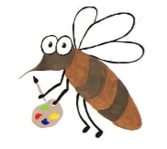

Lyng Primary School Knowledge Organiser

Art

Autumn Term

Year 2

Topic: Australian Adventures

Art

|  |  |
| --- | --- |
| Vocabulary | |
| **Spelling** | **defintion** |
| collage | Art where pieces of paper or fabric have been torn or cut and then glued to a 2 dimensional surface. |
| cut  tear | To separate using scissors.  To separate using hands. |
| line marking | A drawing made up of only straight lines and curves. |
| Pointilism | A technique painting dots of different colour. |
| Sculpture | The art of making a 3D representative. |
| Tone | The lightness or darkness of a colour. |
| Patterns | A repeated decorative design. |

**Background information for parents and teachers**

Children will use paint to create the appearance of texture to replicate a piece of Aboriginal art work.

Children will build upon their sculpturing skills when using clay by using joining techniques and tools to add patterns.

Children will use coloured crayons when making like markings and use to show tone.

Children will create a **collaborative poppy wreath** for Remembrance Day as part of a **whole school event** using collage of tissue paper.

We will begin to learn about how, as artists we can be inspired by other notable artists.

|  |
| --- |
| Skills and techniques |
| * Create a painting using pointillism. * Sculpture clay to form a turtle. * Using coloured crayons experiment with line marking. * Use tone and patterns to create a death mask. * Cut and tear paper to create a collage background. |

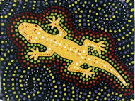

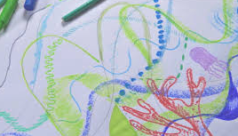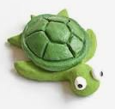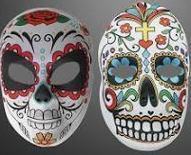

**Collage:**

Collage has been around for a very long time and may have been used by cave dwellers by adding ribbon, slivers of grass and fur to their cave paintings.

In the 20th century, collage became an important technique in

Modern art. 20th century artist who used collage include:

**Henri Mattise** 1869-1954 The snail 1953

**Eric Carle** 1929 – The Very Hungry Caterpillar 1969

Agreed outcomes:

* A piece of Aboriginal Art work
* A clay turtle
* A drawing inspired by waves using lines and patterns (KAPOW)
* A Day of the Dead Death Mask showing pattern, texture and tone (Halloween)
* Diwali Cards
* Collaborative poppy wreath
* Christmas cards using tone
* Calendars using

